William Yung – [yungwilliam@csu.fullerton.edu](mailto:yungwilliam@csu.fullerton.edu)

Michael Lam – [michaellam@csu.fullerton.edu](mailto:michaellam@csu.fullerton.edu)

CPSC 335

Project 4

Exhaustive Search Scatter Plot: Dynamic Programming Scatter Plot:

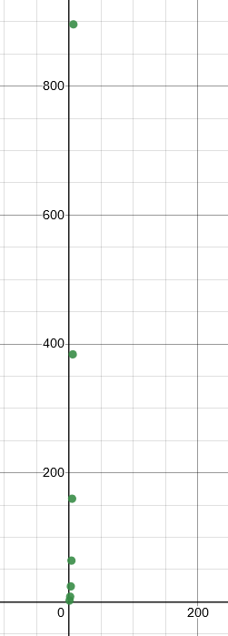 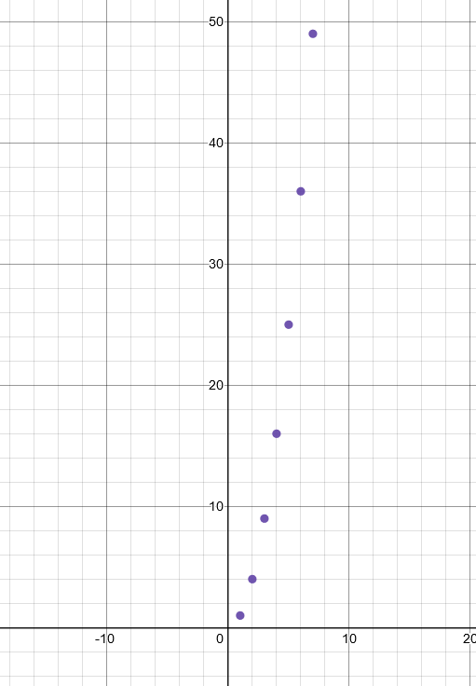

Both Scatter Plots:

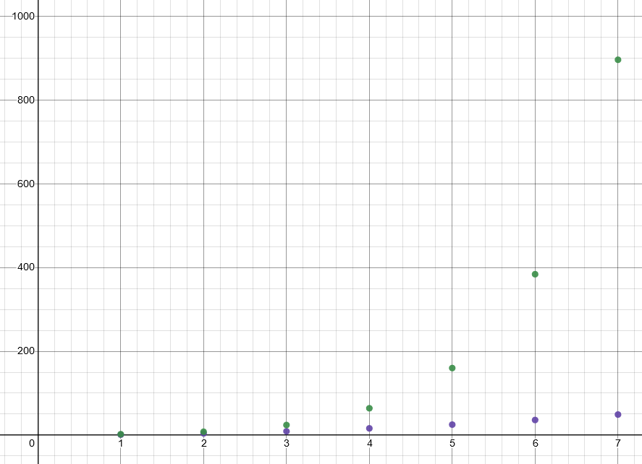

1. They are consistent with the efficiency classes as when looking at the dynamic algorithm plot there is a distinct exponential growth that is comparable to O(n^2).
2. The evidence supports the hypothesis. Looking at the plot with both algorithms at every x point after x = 3 the exhaustive algorithm has a much higher y value indicating that it is slower.
3. The most challenging part of implementing the dynamic algorithm was setting up the conditions. Once the conditions were set there were no problems. The exhaustive algorithm was harder due to the number of conditions required. Dynamic is preferable because there are less lines of code and conditions required making it easier to follow.